Module 1 Critical Thinking Assignment (Calculator)
Platform-Based Development
CSC475-1 Winter 2025 Session A
Mr. Farhad Bari

Grant Brosovich
11/16/2025

The purpose of this program was to create a simple calculator to perform basic arithmetic functions across different Android platforms incorporating different style and theme choices with Material Theme 3 in mind. I built the program in several Kotlin files to build my skills with that language as well as incorporate the JetPack Compose plugin and its functionalities. I used the MainActivity.kt file to initiate the application and assign variables for the compiler to create the visual state of the application. The CalculatorViewModel.kt file provides most of the legwork and effort for ensuring functions and actions are working correctly according to developer desires. This a little difficult to manage all the necessary parts like setting the _uiState.value to a certain condition for each action. Much of the logic of arithmetic actions were simple to incorporate but getting familiar with specific language built-in functions like roundToLong() and isFinite() took a little research to understand and implement correctly.
When building the display format with the CalculatorScreen.kt file it felt familiar, like using html or WebGL to set spacings and values. Kotlin uses the .dp/.sp to determine size based of pixels for that was interesting to learn. I also noticed that when switching from light to dark mode within the Virtual Device itself that my calculator app did change clors but not drastically. I decided to add some custome dark-theme settings in the Theme.kt under the UI folder. I used Android Studio’s guide for custom theme practices to find which values needed to be changed and then added those references to the respective Text() and Column() sections in my CalculatorScreen.kt file (Android Studio, n.d.). Below are images running the application in a standard phone Virtual Device and a Pixel Tablet in Dark Mode.
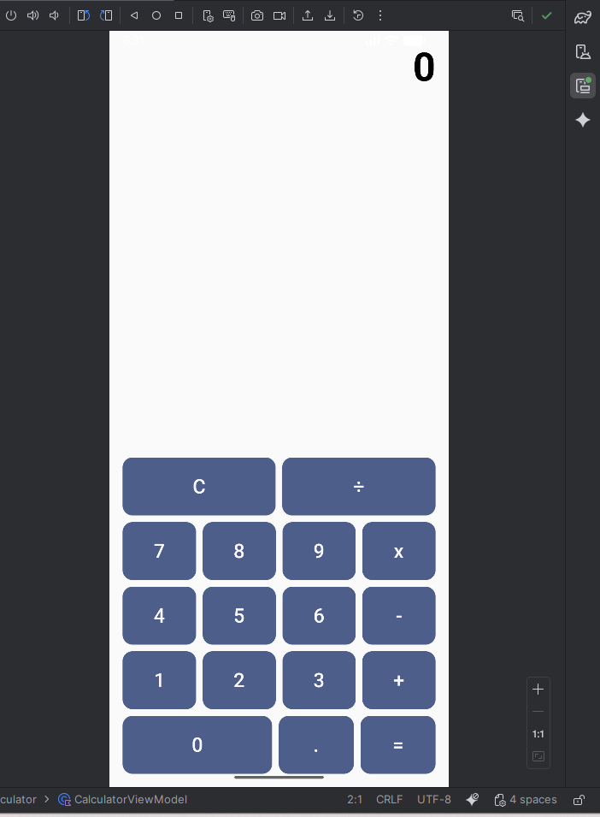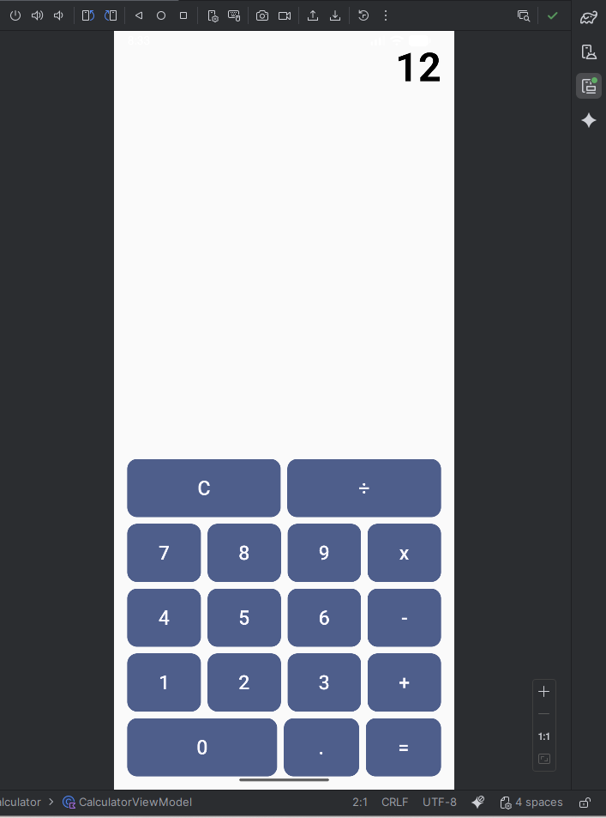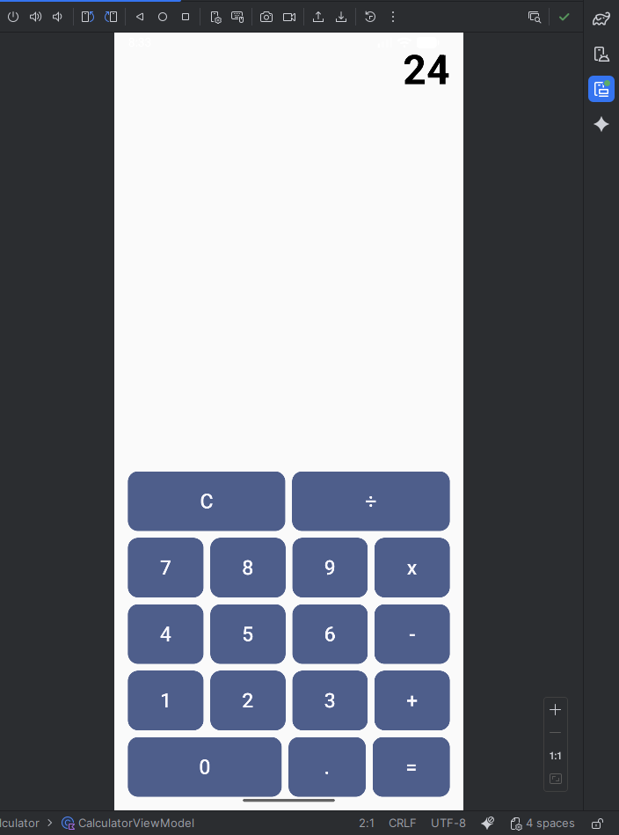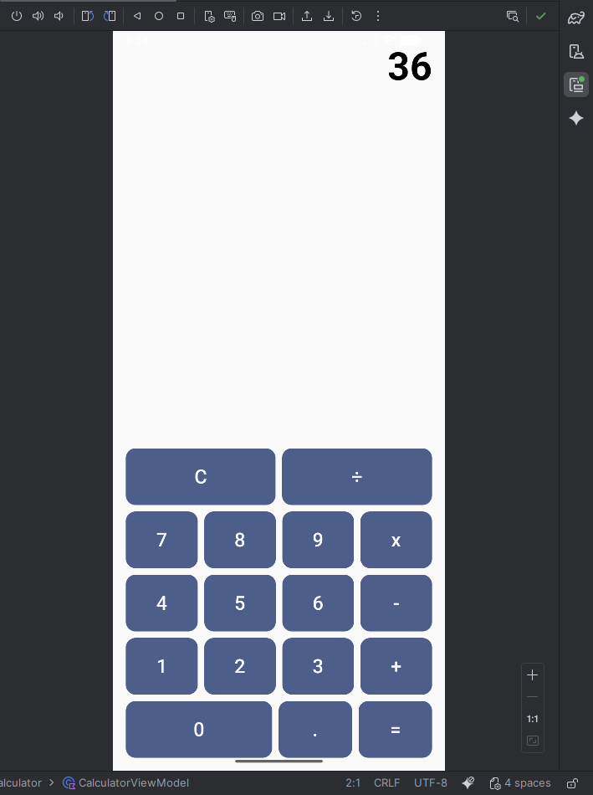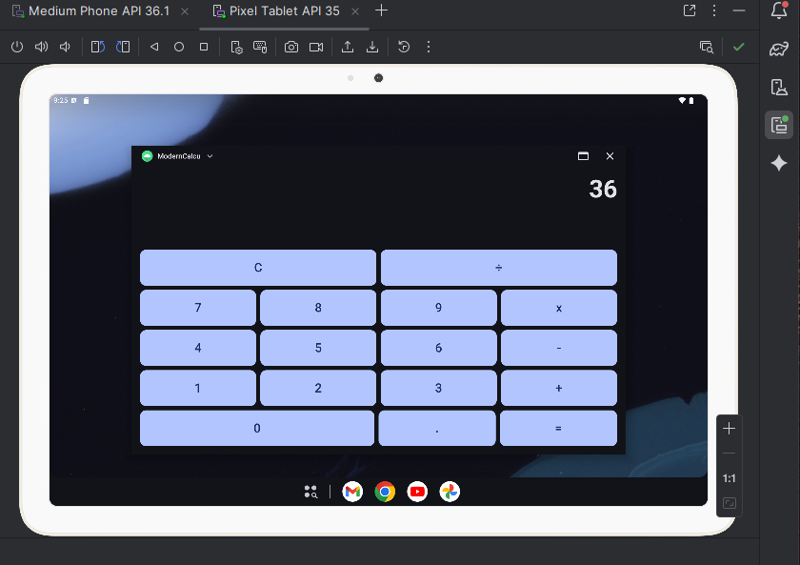
References:
Android Studio. (n.d.). Custom Design Systems in compose : Jetpack Compose : android developers. Android Developers. https://developer.android.com/develop/ui/compose/designsystems/custom
Public GitHub Repository:
